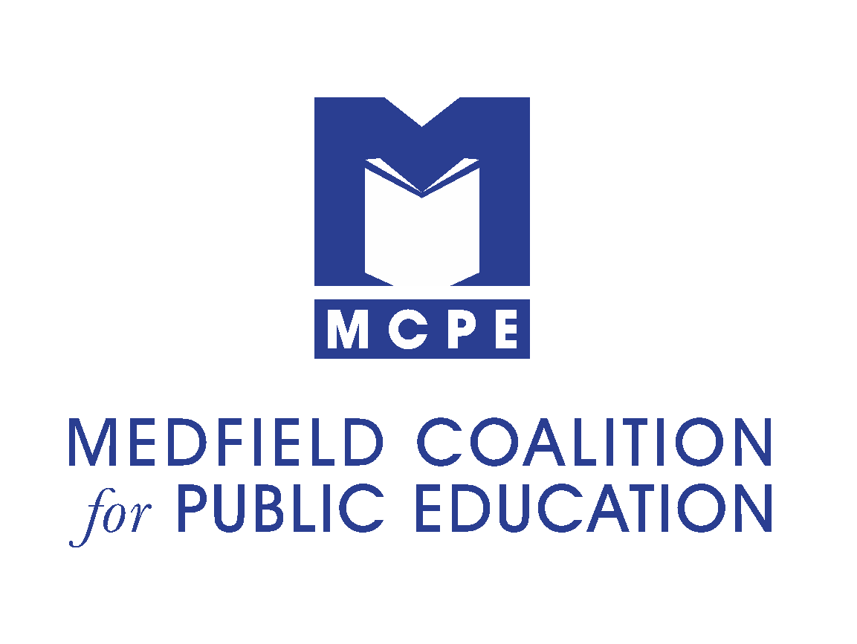
The Robert C. Maguire
Global Perspectives in Education Award

Application Form

Criteria:

This award will be given to a staff member whose effort embodies Bob's vision for further developing students' global understanding and readiness to engage in the expanding global economy. Similar to Bob, the award recipient will be someone who inspires students to look beyond the town of Medfield and learn more about the global community through innovative programs and technologies. This may include initiatives that:

A. Use innovative technologies to enhance learning, foster collaboration, and develop connections with other people and communities

B. Increase multicultural awareness and appreciation

C. Bring multicultural elements into the curriculum

D. Develop links with schools or organizations in other nations or different ethnic communities within the US

Nominee’s Name: _______________________________________

Nominee’s position: _____________________________________

Nominated by: _________________________________________

Today’s Date: ___________________________________________

In what capacity do you know the nominee?

____________________________________________________

Describe in 400 words or less why the nominee would be a worthy recipient of the Robert C. Maguire Global Perspectives in Education Award:

Application must be received by the Medfield Coalition for Public Education by April 30,2020.
For questions regarding this award, please contact mcpeboard@gmail.com.

Please email completed applications to mcpeboard@gmail.com

